Precision Castparts Corp. (PCC) Structurals, Inc.

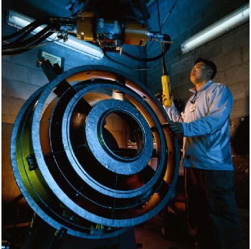
A major Milwaukie employer for 50 years, Precision Castparts Corp. (PCC) initially joined the city’s business community in 1955 with 40 employees in one building. Today, the global castings manufacturer employs over 1,000 in Milwaukie and PCC announced a plan to invest an additional $25 million in its Milwaukie facilities in 2007.
“One of the many benefits of our Milwaukie location has been the ability to expand when we’ve needed to,” says Ross Lienhart, President of PCC Structurals, “and to do so by buying or leasing facilities in near proximity.”
The local casting business first located in the city in 1955 at 5001 SE Johnson Creek Blvd. By 1957, its workforce had doubled in size and it moved to a nearby Harney Drive site, but it repurchased the Johnson Creek building in 1981 – now the site of its 225,000-square-foot Titanium Business Operation, the world’s leading manufacturer of titanium castings.
Between 1978 and 1990, PCC leased 94,000 additional square feet of space in four different buildings in the Johnson Creek Crosswhite Industrial Park. One building serves as a machine shop, two are back-end production (finishing) areas and one provides storage. In 1990, the company began leasing 50,000 square feet in another industrial plaza off Highway 224 and Johnson Road for a distribution center and records warehouse. And in 1998, the company occupied its 120,000-square-foot Deer Creek facility, now dedicated to industrial gas turbine component manufacturing.
At a Glance: PCC Structurals
Established in 1953, Precision Castparts Corp. is a worldwide, diversified manufacturer of complex metal components and products. It serves the aerospace, power generation, automotive, and general industrial and other markets from more than 80 facilities in 22 states and 16 countries. Its global workforce totals more than 16,000.
The PCC Structurals division is the world market leader in manufacturing large, complex structural investment castings for critical applications in the aerospace market. (Aerospace clients include Airbus Industrie, Boeing and McDonnell Douglas.) It is also a major market player in the casting industry for medical, general industrial, alloy and other commercial applications, and is rapidly expanding its niche in the industrial gas turbine market.
The PCC Structurals division alone generates annual sales exceeding $350 million.
Benefits of staying locally include excellent transportation access and a stable local work force, Lienhart says. “The proximity to freeways such as I205 and to the Portland International Airport are a definite advantage. We usually ship by truck, but when we need to airship parts, we have that option,” he says. The area also provides access to both a local and regional labor pool. “About three-quarters of our hourly workers come from fairly close-in neighborhoods, and some of our employees have been with us for 40-45 years. For our professional staff, we have the option of pulling from the more regional market in the Portland metropolitan area.”
The bottom line, Lienhart says, is that the Milwaukie-based PCC group (now part of PCC Structurals, a division created in 1996), has always felt “very comfortable” doing business here. “Our business can be cyclical,” he says. “When we’re growing, as right now, we’ve always been able to accommodate that growth seamlessly. We’ve never felt constrained and have been able to meet most of our needs close to where we started out.”
www.precast.com

