Bob’s Red Mill

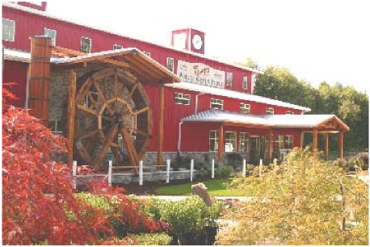
Bob Moore of Bob’s Red Mill Natural Foods is one of the most well-known faces around Milwaukie. A fixture in the city for two decades, Bob’s unique enterprise is the most recognized landmark in town – and with Bob’s likeness sketched into the company logo, he’s our foremost public figure.
Bob and his wife, Charlee, located their business at 5209 SE International Way in 1988 after a tragic fire razed their first Oregon mill. The couple, already Milwaukie residents and attending a local seminary school, saw no reason to stray far from home.
“We love everything about this community and were thrilled to locate closer to home,” says Bob Moore. “Plus, we were very happy with our established shipping network. This is a superior transportation hub and our major distributor is located nearby in Clackamas.”
At a Glance: Bob’s Red Mill
Bob’s Red Mill features all-natural whole grain products milled the old-fashioned way – with slow turning quartz millstones hand-picked for the job. Established in 1978, the privately owned company has become a multimillion-dollar business milling, packaging and marketing over 300 different whole grain products throughout the U.S., Canada and overseas.
The company is as much a calling as a business for owners Bob and Charlee Moore. It combines his love of “tinkering” with machinery with her long held devotion to feeding her family wholesome foods (even during the frozen “TV dinner” era of the ‘50s!). Their two interests, fueled by a strong belief in ministering to the public’s health, gave birth to a natural foods business first in California and then Oregon.
How has a Milwaukie location helped Bob’s Red Mill flourish? Besides offering an excellent transportation system, the city has been diligent about easing other potential bottlenecks, Moore says. “They (city officials) have been especially easy to work with. When we ran up against a few impediments during our recent expansion, the mayor himself (Jim Bernard) stepped forward to advocate for us. He was very hands-on. We had a sense that the city really valued our business.”
After serving on the city’s Economic Development Advisory Committee, Moore has observed the city’s commitment to business on a wider scale. “I’ve been impressed by the city’s focus on partnering with the business community,” he says. Likewise, Bob’s Red Mill has partnered with the city’s police department to sponsor several initiatives. “It’s very comforting to us to have this kind of rapport with local law enforcement,” he notes.

Moore also credits Milwaukie and the surrounding community for supplying an excellent labor force. “We’ve been able to create scores of long-term, family-wage jobs because of this stable work force.” With a renewed national focus on improving the American diet, Bob’s Red Mill continues to expand both its product line and services.

In 2008, Bob's Red Mill moved their primary production facility just down Highway 224 to Pheasant Court. The move allowed the company to more than double their building footprint. To replace Bob's Red Mill at the 5209 SE International Way building, the City welcomed Nature Bake, makers of Dave's Killer Bread. Bob's Red Mill still operates their gift store and restaurant at 5000 SE International Way -- and the City is now proud to host both of these leaders in the organic food industry!

www.bobsredmill.com

