Advantis Credit Union

One of the area’s oldest nonprofit financial cooperatives, Advantis Credit Union has occupied a site at 10501 SE Main St. in Milwaukie since Electra Central Credit Union (ECCU) merged with the former Rose City Credit Union in 1996.
When space became cramped, ECCU chose to rebuild on-site rather than move -- resulting in a three-story, 22,000-square-foot administration building with additional leasable office and retail space and parking. Completed in early 2003, the building now houses credit union administration employees on its third floor and a major tenant, the Active Group, on its second floor.
The decision to stay in Milwaukie just made good sense, according to Cindy Barrick, ECCU’s CEO and President. “The location is so conveniently located, with access to I-5, I-205, and Highways 43 and 224, that our staff can commute easily from anywhere in the Portland metropolitan area,” she says, “and we found working with the Mayor's office and the city planner a good experience. They are accessible and business friendly.”
“There are just so many advantages to this location,” Barrick says, noting the city’s “small town feel” amidst a major population area, a cohesive Downtown Improvement Plan and opportunities for growth. “Not to mention,” she adds, “we can avoid Multnomah County taxes here.”
www.advantiscu.org

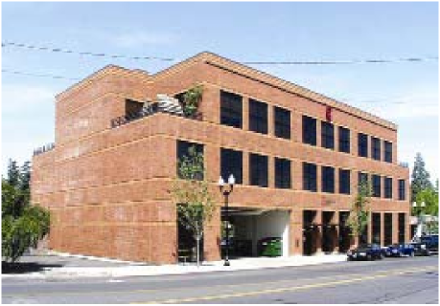

At a Glance: Advantis
Electra started out in 1928 serving employees of public utilities such as Rose City Transit and the predecessor of Portland General Electric. Today, Advantis serves more than 30,000 members – including employees and retirees of PacifiCorp, public transit agency Tri-Met and some 350 additional businesses – from branches in downtown Portland and both northeast (Lloyd District) and southeast Portland.
Advantis offers competitive low-cost financial tools, including checking and savings accounts, online banking and banking by phone, mortgages and auto loans, and investment and financial planning services. The credit union annually provides three $1,000 scholarships to selected college students who are members or related to members.
In 2005, Electra merged with PACE Credit Union, which had been serving local public employees since 1936, to form Advantis. The move nearly doubled membership and created a joint asset base of $470 million.

