Canby Urban Renewal District
Sponsor: City of Canby
Year Formed: 1999

Purpose: To diversify economic base and family wage jobs within the district. To maintain effective, efficient and safe traffic system for vehicular and pedestrian users. To improve and retain existing businesses. To improve attractive visual amenities for customers and community members throughout the district.

Area: The district is 573 acres, 382 of which are within City limits. The district encompasses the core of downtown and some under-utilized industrial lands.

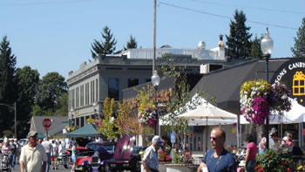
Key Projects/Programs:
- Industrial job creation incentives (SDC cost defrayal)
- Industrial infrastructure investment (allowing opening of 300 acre industrial park)
- Downtown streetscape and beautification
- Downtown parking

Clackamas Industrial Area
Sponsor: Clackamas County
Year Formed: 1984; amended in 2001; TIF collection completed in 2006

Purpose: To reduce traffic congestion, control flooding and improve drainage, promote economic development and create new jobs for local residents in a regional distribution, warehousing and wholesale trade center.

Area: 2,173 acres when first formed; approximately 1,187 acres after amendment.

Assessed Value: Original assessed value in 1984 of $300 million for 2,173 acres. $253.5 million was returned to the general tax rolls in 2001 and another $300 million was returned in 2006.

Key Projects:

- Sunrise Corridor (ROW acquisitions)
- 172nd Ave. Improvements
- Circulation improvements: Highway 212, Jennifer Extension/Southeast 135th Avenue, and Evelyn Street Overpass at 82nd Drive
- Site acquisitions to allow flood management and redevelopment

Clackamas Town Center Area
Sponsor: Clackamas County
Year Formed: 1980

Purpose: To provide transportation and community facilities in an area expected to grow rapidly.

Area: Approximately 819 acres of land in the north part of unincorporated Clackamas County between the cities of Milwaukie and Happy Valley.

Assessed Value: $458 million in 2007, up from $45 million in 1980; $90 million of incremental assessed value returned to general tax rolls in 1987 and $48 million returned in 2005.

Overview: The Clackamas Town Center area is the region's fastest growing business center. In the last 25 years many high quality office, retail and multifamily projects have been built. Long-term success depends on achieving a balance of access and amenities that attract residents, businesses and future development. The biggest challenges have been funding transportation projects and providing enough parks, open space and public places.

In June 2005 the Clackamas Town Center plan was amended in the following ways: approximately one acre was added for construction of a public parking garage at the Town Center ; 88 acres were withdrawn from the urban renewal district and returned to the general tax rolls; and a site was identified on Harmony Road, the current location of the Clackamas Community College/Oregon Institute of Technology campus, as an area for possible redevelopment activities.

Key Projects:

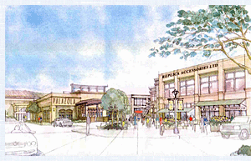
- Sunnyside Road projects (road capacity improvements)
- I-205 Light Rail
- Mixed-use, residential and commercial development projects
- New local road connections
- I-205/Johnson Creek interchange
- Land acquisition and other support for community facilities, including fire, public safety, affordable housing, recreational, community college, and library projects.
- Clackamas Town Center Mall redevelopment
- Monterey Main Street
Government Camp Village
Sponsor: Clackamas County
Year Formed: 1989

Purpose: To target public investments toward revitalizing the community and encourage private developments such as resorts, hotel and condominium units, retail projects, restaurants, recreational facilities and single family homes.

Area: Approximately 8,960 acres on the west slopes of Mt. Hood.

Assessed Value: $108 million in 2006-07, up from $24 million in 1989; will collect tax increment financing revenues through 2007-08.

Key Projects:

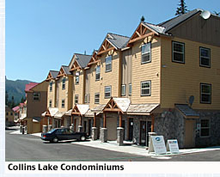
- Utility undergrounding & core area streetscape improvements
- Transportation infrastructure: Multorpor Overpass Replacement, Trail improvements
- Essential infrastructure: Sewer and Water Line Extensions & new sewer treatment capacity
- Development Assistance (contributions to façade improvements, fire sprinklers, rehabilitation, and new utilities for commercial and residential projects, including an affordable housing project)
- Planning and Design projects

Lake Oswego East End Redevelopment Plan
Sponsor: City of Lake Oswego
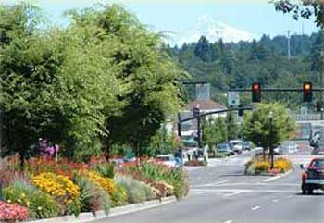
Year Formed: 1986

Purpose: Catalyze and support the redevelopment of the East End commercial area of Lake Oswego, in order to create pride in the area, enhance shopping services, utilize the unique physical characteristics of the area, and improve the tax base of the entire city.

Area: 168 acres encompassing the heart of downtown Lake Oswego.

Assessed Value: Frozen base of $45.8 million; Total AV over $200 million.

Maximum Indebtedness: $59 million

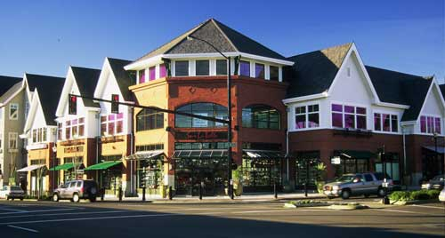

Key Projects/Programs:

- Streetscape Improvements and utility undergrounding: State Street, A Avenue, First Street, Fifth Street, and others
- Downtown façade improvement grant program
- Land acquisition for downtown mixed use redevelopment projects
- Millenium Plaza Park & Lakewood Bay boardwalk

North Clackamas Revitalization Area
Sponsor: Clackamas County
Year Formed: 2006

Purpose: To support the development of the North Clackamas area community, including the Overland Park neighborhood, as a safe, clean and affordable mixed use residential neighborhood that provides retail, economic, educational, transportation and recreational opportunities, and a sense of identity and place for its diverse citizenry.

Area: Approx. 1,008 acres between Milwaukie and Happy Valley.

Assessed Value: $398 million in 2007.

Key Projects:
- public utilities, including sewer extension;
- public parks and open spaces;
- public buildings and facilities;
- street, curb and sidewalk improvements;
- streetscape and neighborhood beautification;
- preservation and rehabilitation of housing and commercial property, and
- development and redevelopment of housing and commercial property.

Oregon City Downtown Urban Renewal Plan
Sponsor: City of Oregon City
Year Formed: 1983

Purpose: To improve public facilities, including streets, pedestrian and bicycle facilities, inadequate park and recreation facilities, inadequate sewer, water and drainage facilities. To make public improvements necessary to encourage new private investment in underdeveloped land in and around the downtown area, to improve the economic viability of Oregon City's downtown as a retail, office, and services center and mixed-use area for Oregon City.

Area: Approx. 855 acres includes the Downtown area, Clackamette Cove, Landfill redevelopment site, Washington/7th Corridor, and Heritage Center areas. (The Hilltop District was closed in 2005, after realizing a 1,100% increase in AV.)

Maximum Indebtedness: $130 million.

Key Projects:
- Parking, street and transit improvements, including McLoughlin Boulevard, Main Street, future light rail, Amtrak station, and streetscapes.
- Transportation improvements to specifically support Clackamette Cove and The Rivers developments
- Public facility purchase (City Hall / Library)
- Parks and open space improvements
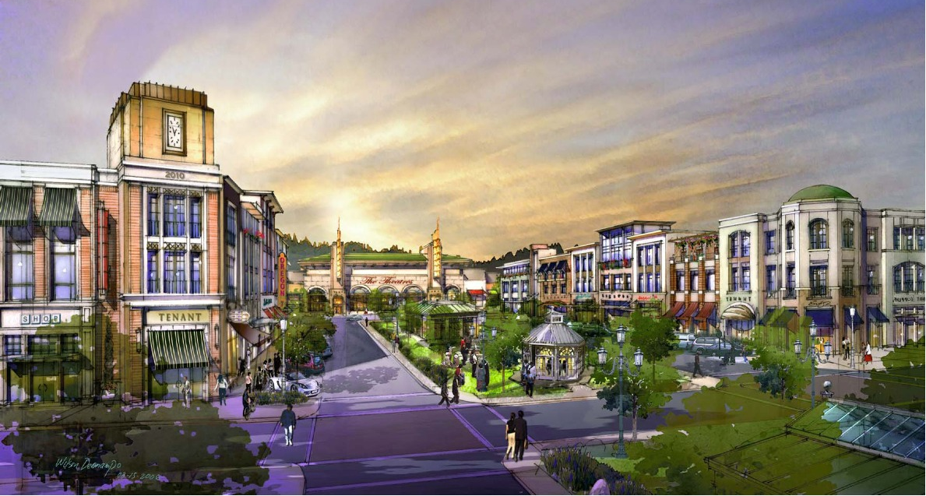
- Support private sector development through loans and grants

Sandy Urban Renewal Plan
Sponsor: City of Sandy
Year Formed: 1998

Purpose: Invest in key public infrastructure to support downtown reinvestment and development

Area: Downtown Sandy.

Maximum Indebtedness: $18 million

Overview: The Sandy district focused on a limited, focused number of projects to improve key aspects of the downtown area. The initial bonds were paid off and the City is recently extended the life of the district. Possible future projects of interest are a matching grant program to assist with façade improvements and public facility improvements (public safety and/or library).

Key Projects:

- Sidewalk, streetscape, street trees, and street lighting improvements
- Utility undergrounding
- Public parking improvements
- Public plaza or park

Wilsonville East Side District / Year 2000
Sponsor: City of Wilsonville
Year Formed: 1992

Purpose: Fund infrastructure improvements in portions of “Old Town” and to allow new development in relatively under-developed portions of the East Side.

Area: 857 acres primarily on the east side of I-5 but including “Old Town” (on the west side of I-5) south of Wilsonville Road and east of Boones Ferry Road.

Assessed value: $30 million at establishment.

Overview: Since its inception, the East Side District has seen (1) assessed property valuation increase by $300 million, and (2) over 3,000 jobs added. Prior to Plan adoption in 1992, the area was largely undeveloped. Transportation, infrastructure and parks improvements provided much needed investment in the Area to make it attractive for private development.

Since 2004, 225 acres of developed property has been removed from the District and returned to the tax rolls. This included the Mentor Graphics and Sysco Food System developments. The removal of these taxable properties resulted in the return of $60 million in assessed value to the tax rolls and $960,000 of tax revenue received by the various taxing districts.

Key Projects/Programs:

- Transportation improvements including street construction/reconstruction such as Town Center Loop extensions and Wilsonville Road; and new I-5 over-crossing and interchange improvements
- Water/sewer/storm sewer projects
- “Old Town” streetscape improvements
- Community facilities: improvements to existing parks and new parks, recreational, and civic facilities

Wilsonville West Side District
Sponsor: City of Wilsonville
Year Formed: 2003

Purpose: Fund critical infrastructure investments to allow development of a mixed-use “urban village” and additional development lands.

Area: 395 acres on the west side of I-5, including the Villebois Master Plan area and some property located south of Wilsonville Road (including both incorporated and unincorporated areas).

Assessed Value: $3.4 million at establishment.

Overview: The $40 million infrastructure investment represented by the West Side Plan will leverage over $500 million in private development. Villebois, the model urban community under construction on the former Dammasch Hospital site, will provide the revenue stream from its increased property values to fund the West Side District. These funds will pay for bonds used for street and other improvements without assessing new taxes to current residents and businesses. In addition, Villebois will help address Wilsonville's critical housing shortage. It will offer housing options for those that now commute here for work.

Key Projects/Programs:

- Road construction/reconstruction/widening and utility undergrounding
- Multi-modal improvements, including trails, sidewalks, and transit infrastructure
- Piped infrastructure improvements: public sanitary sewer, water service and storm drainage
- Parks and open space investments
- New elementary school and related playfields

